Project Design Phase-II
Data Flow Diagram & User Stories

Date | 15 Feb 2026
Team ID | LTVIP2026TMIDS86493
Project Name | Shop Smart
Maximum Marks | 4 Marks

Data Flow Diagrams:
A Data Flow Diagram (DFD) illustrates how data moves within the Resolve Now platform. It captures how user interact with the system, how information flows between different components, and where the data is stored.
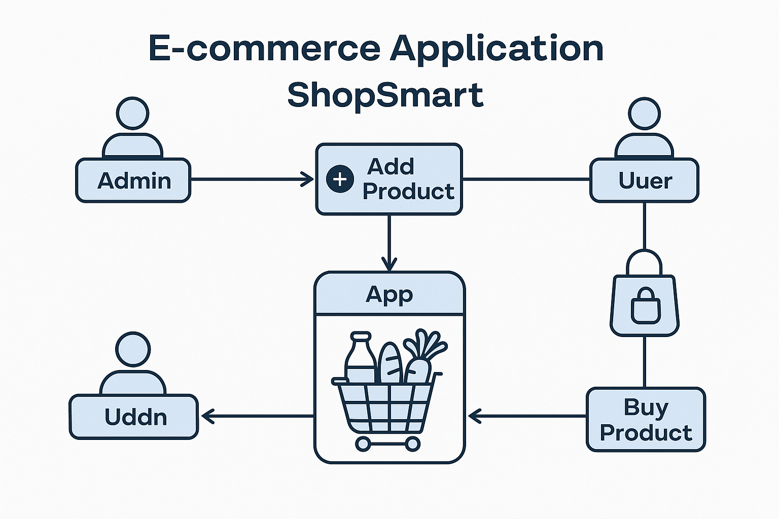

User Story Table – Shop Smart
User Type | Functional Requirement (Epic) | User Story / Task | Acceptance Criteria | Priority | Release
Admin |  | As an admin, I can add new grocery products to the app. | Products appear in the product listing for users. | High | Sprint-1
  Product Management
Admin | Inventory Control |  |  | High | Sprint-1
  As an admin, I can update or delete existing products.
  Changes are reflected in
  real-time to users.
User |  |  |  | Medium | Sprint-2
  Product Browsing
  As a user, I can browse all available
  grocery products.
  All listed products are
  visible with details like
  price and quantity.
Client |  |  |  | High | Sprint-2
  Add to Cart
  As a user, I can add items to my
  shopping cart.
  Selected items appear
  in the cart with correct
  quantity and total.
Admin |  |  |  | High | Sprint-1
  Order Management
  As an admin, I can view and process
  user orders.
  Admin dashboard shows
  new orders and their
  statuses.

